**WRIST-HAND ORTHOSIS**

Diagnosis:

Priscription:

Affected Side: Left Right Bilateral

Material: Low-Temperature Thermoplastic High-Temperature Thermoplastic

Other:______________________

Type of WHO: Dynamic Static

Side To Cover: Palmar Pocket Dorsal Pocket Ulnar Pocket

**Splinting Position Of Joints**

**Wrist Joint:** Flexion Range Extension Range Neutral Position

**MCP:**  Flexion Range Extension Range Neutral Position

**IP Joints:**  Flexion Range Extension Range Neutral Postion

**Assistance Needed to Joints**

**Wrist Joint:** Flexion Extension

**MCP Joint:** Flexion Extension

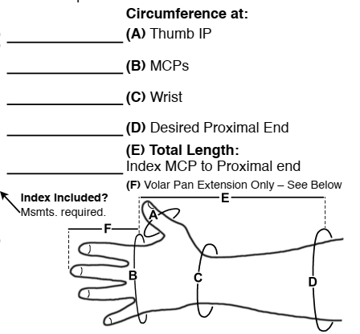**IP Joints:** Flexion Extension

**Hand Trace:**